Game Design Document

Fill up the Following document

1. Write the title of your project.

**Corona Warriors**

1. What is the goal of the game?

To make the people aware of the safety from corona virus and to dedicate to the hard working corona warriors

1. Write a brief story of your game?

In this game the player will be able to pick a character either of a doctor or a police and tell them the necessary things to do.

Like if the player chooses the character of a doctor he/she will treat patients and at last will tell the safety measures and symptoms of

Corona virus . if the player chooses the character of a police he/she will stop people from coming out of the home and at last the police will tell every one to stay at home and work from home.

When the game ends we I will display a tribute message for the corona warriors not only doctors or police but more warriors like sweepers, chemists ,scientists ,delivery workers etc….

1. Which are the playing characters of this game?

* Playing characters are the ones which respond to the user based on the input from the user
* Cars, monkeys, dinos, wizards etc, are the playing characters in the game.

|  |  |  |
| --- | --- | --- |
| Number | Character Name | What can this character do? |
| 1 | Doctor | Have to treat paitents |
| 2 | police | Stop people from going out |
| 3 |  |  |
| 4 |  |  |
| 5 |  |  |
| 6 |  |  |
| 7 |  |  |
| 8 |  |  |

1. Which are the Non Playing Characters of this game?

* Non Playing characters are the ones which don't have an action or a behaviour when the user interacts with the game.
* Hurdles, stones, bananas, coins, etc are non playing characters in the game.

|  |  |  |
| --- | --- | --- |
| Number | Character Name | What can this character do? |
| 1 | People | Going out of their home |
| 2 | People2 | Having corona virus |
| 3 |  |  |
| 4 |  |  |
| 5 |  |  |
| 6 |  |  |
| 7 |  |  |
| 8 |  |  |

Draw your imagination of this game. What does this game look like?

* Draw the game either on your computer or on paper,
* Add images of scenes of the game to show each of the playing and non-playing characters at least once.

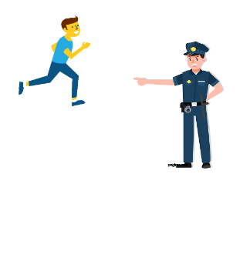

How do you plan to make your game engaging?

By giving lives, by creating some obstacles , adding sounds and making the game little difficult.